Analysis Tool Manual V2.0

Table of Contents
1. Overview 4
2. Interface Functional Description 5
2.1. Menu Bar 5
2.1.1. File 5
2.1.2. Edit 6
2.1.3. Settings 6
2.1.4. Help 9
2.2. Tool Bar 10
2.3. File List 10
2.3.1. Batch Delete Button Area 10
2.4. Home Page 11
2.4.1. Preview screen 11
2.5. Browse Page 11
2.5.1. Report information 11
2.5.2. Test Device Information 11
2.6. Preview interface 11
2.6.1. File name display 12
2.6.2. Picture/video display 12
2.6.3. Video playback switch frame button 12
2.6.4. Function buttons 12
2.6.5. Test Point Information 13
2.6.6. Picture information 13
2.6.7. File Annotation 14
2.6.8. Locked Pictures（Video File） 14
2.6.9. Time Domain Waveform 15
2.6.10. PRPD（Electricity） 16
2.6.11. Test Result Determination 17
2.6.12. Economic Loss Estimation (Gas) 18
Appendix A Custom Gas Report (XLSX) 19
Appendix B Custom Electricity Report (XLSX) 22
Appendix C ISO50001 Gas Report (PDF) 26
Appendix D ISO50001 Electricity Report (PDF) 30

Overview
This software is specially adapted to the CRY26XX Handheld Acoustic Imager to view and analyze data from pictures and videos taken by the imager, and to edit and output the corresponding test reports. It is only available for Windows.

Interface Functional Description

Menu Bar

File
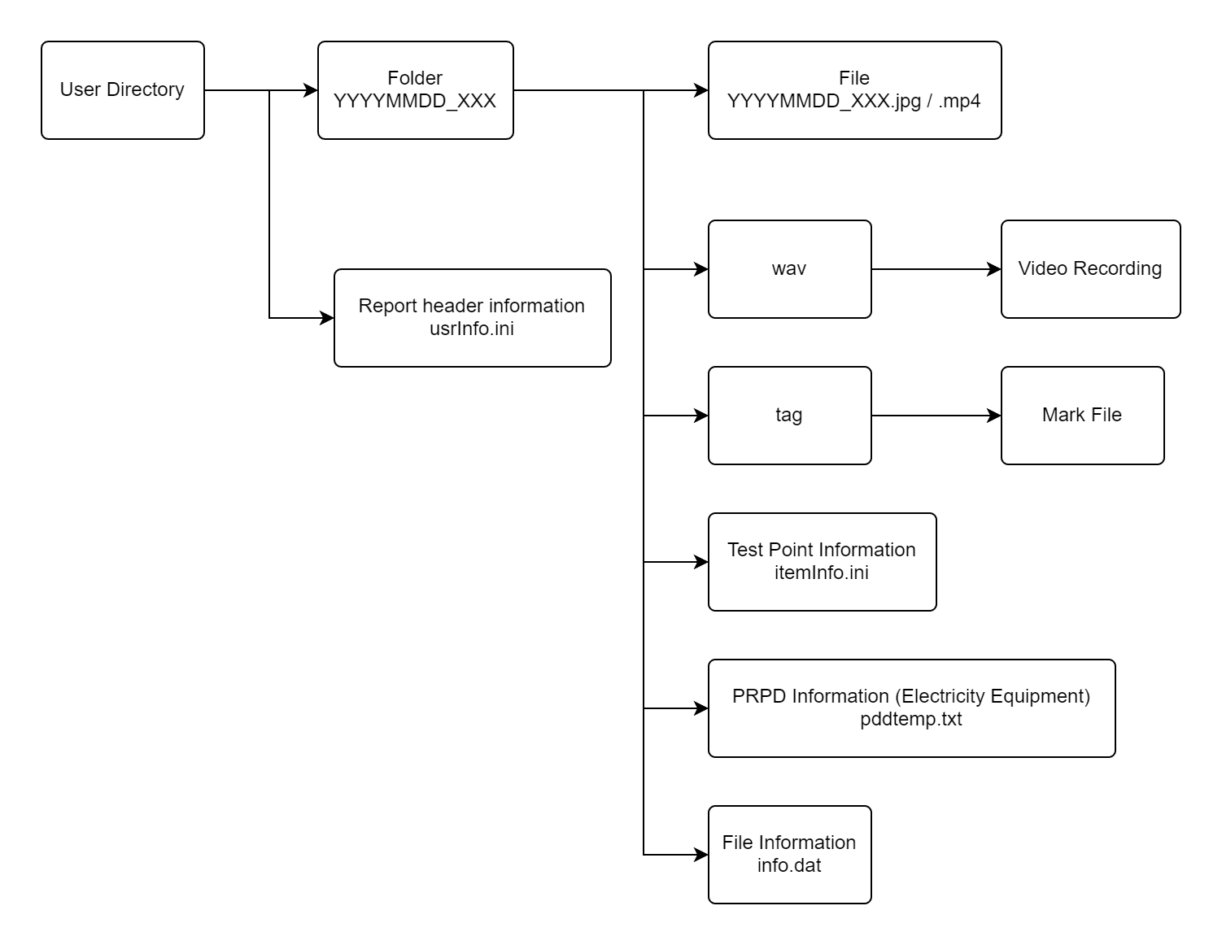
File storage format (may vary slightly depending on device firmware version)

Import
Import the file to be analyzed and select the path to the user directory corresponding to the file;
You can import user directories only if you have the usrInfo.ini file, otherwise you cannot import them, and you can only open one user directory at a time;

Delete
Delete the currently selected file from the file list, local files are not deleted.

Delete in Batch
When you click to enter the batch deletion status, the "Batch Delete Button Area" is displayed, and you can't switch the file view.

Edit

New Report
New report page (power/gas), support for multiple report pages, up to 30

Export Report
Export the report page currently being edited
- Custom
Simplified Chinese/English only, XLSX format
- ISO50001
PDF format

Settings

Language
Set software/report language, 6 languages available

Network Settings
Specifically adapted to Handheld Acoustic Imaging Equipment with static IP functionality

Function
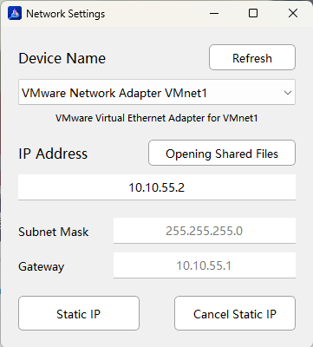
- Refresh：retrieve and get the list of computer NIC names (when there are NIC changes, you need to manually click the refresh button)
- IP Address：to be set the static IP address of the NIC (10.10.55.xxx, except 10.10.55.55)
- Opening Shared Files：when the computer is successfully connected to the equipment, open the TF card storage path of the sound camera (the CRY26XX needs to be inserted with a TF card)
- Subnet Mark：Default, cannot be changed.
- Gateway：adapted, cannot be changed
- Static IP：applies the "IP address" to the currently selected network card
- Cancel Static IP：cancel the static IP of the currently selected NIC and set it to a dynamically obtained IP address.

Operation
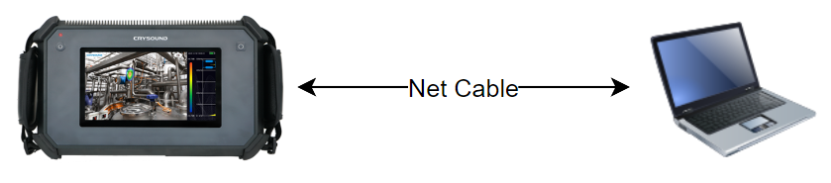
Device and computer connection method
- Connect the camera to the computer as shown above.
- Open the "Network Settings" interface and click the "Refresh" button to get the list of network card names.
- Select the name of the network card connected to the camera.
- Edit the "IP Address".
- Click "Static IP" button.
- Wait 1-2min (until the network card applies the IP and connects to the Handheld Acoustic Imaging Equipment) and click on the "Open Shared File" button to operate the file.
- (optional) Click "Cancel Static IP" button after operation is completed.

Economic Loss Parameters
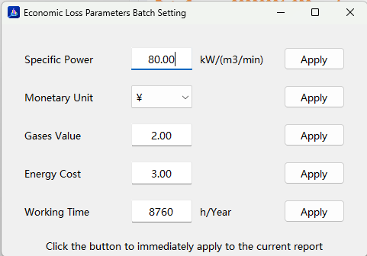
Economic loss parameter setting interface
The parameters are adapted to the functional parameters in the CRY26XX;
- Apply：Apply the corresponding parameters to all selected test points in the current gas report and any future added test points (if the test points do not have default parameters). Only change the currency unit symbol without performing currency conversion.

Help

About
Description of the software version and software usage;

Tool Bar
Toolbar buttons
From left to right the shortcut functions are: Import File, Delete File, Batch Delete, New Gas Report, New Electricity Report, Export Customized Report, Export ISO50001 Report, Economic Loss Parameter, Language;

File List
Displays a list of imported files;
- In Browse Page
Click on the file to view and switch;
- In Report Page
Checking the checkbox adds the corresponding test point to the current report page;
Unchecking the box removes the corresponding test point from the current report page;

Batch Delete Button Area
After clicking "Batch Delete Files", a button area is displayed above the file list;
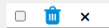
Batch Delete Button Area
- Checkbox: select all/unselect all files
- Delete: batch delete selected files
- Cancel: exit batch delete status

Home Page

Preview screen
Preview and display files, view file information: File name display, image/video display, video play and frame switching buttons, file tag information, image information, file annotations, time-domain waveform, PRPD spectrum.

Browse Page
Report page header information
Can be modified and save;

Report information
Reads and displays the contents of usrInfo.ini in the imported user directory, which is exported to be displayed in the report;

Test Device Information
Same reporting information;

Preview interface
Preview the displayed file, view the file information, analyze the file, and form the report content (preview interface is described separately). The added test point is a preview interface, and the maximum number of test points that can be added to each report is 100.

File name display
Displays the name of the currently viewed file;
Current file name display

Picture/video display
Display the selected file picture/video;

Video playback switch frame button
Tip：Display when video file
Playback progress, video operation buttons
Frame switching button: when the file is a video, picture frame switching for the currently playing video. Switch one picture frame at a time

Function buttons
Tip：Displayed when video file
Function buttons
- Lock button: lock a frame in the video, only one picture can be locked; the picture is exported to the report
- Intercept Video: Intercept a video, if there is a video recording, then the audio will be intercepted together.
- Export with report (customized report): when selected, the intercepted video and audio will be exported with the report.

Test Point Information
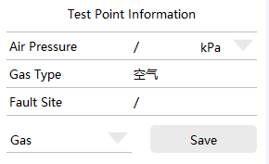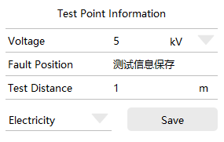
Gas/Electricity Type Label Information
Read the content information of itemInfo.ini in the corresponding file and display it;
If the file does not exist, the default display is the same type content as the report page type; can be edited and modified;

Picture information
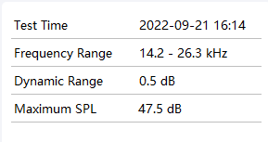
Picture information parameter display
Parameter information corresponding to the current picture;
Maximum sound pressure level is obtained by text recognition, supports modification, and this parameter is exported to the report; when viewing video files, parameter information of locked pictures is exported;

File Annotation
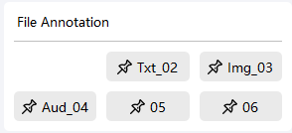
Document annotation information view
Annotation information added to the CRY26XX Handheld Acoustic Imager: Picture Annotation (Img), Audio Annotation (Aud), Text Annotation (Txt), click the button to view;

Locked Pictures（Video File）
Tip：Display when video file
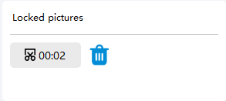
Locked picture viewing area
Locked picture timestamp in video;
- Timestamp: click button, video slider moves to timestamp position
- Delete: button to unlock

Time Domain Waveform
Tip：Display when video file
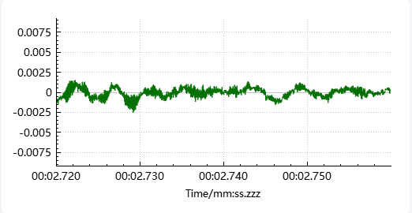
Time-domain waveform curve of the image frame
Draws the time-domain waveform graph of the audio data for the current image frame. If there is no audio data or it cannot be read, it will display a blank space.
If the file contains audio data, clicking on the waveform area will display a time-domain waveform interface consisting of a time-domain waveform, spectrum graph, and spectrogram.

Time Domain Waveform
Including the entire audio data, the red vertical line indicates the current position of video playback.
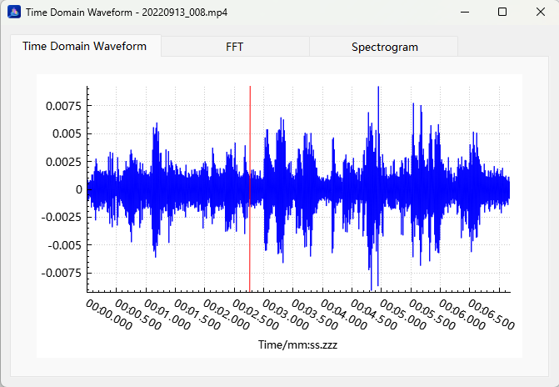

FFT
It includes the audio data of the current image frame. The vertical axis can be switched between displaying dB values and raw values by selecting or deselecting the "Raw Value" radio button.
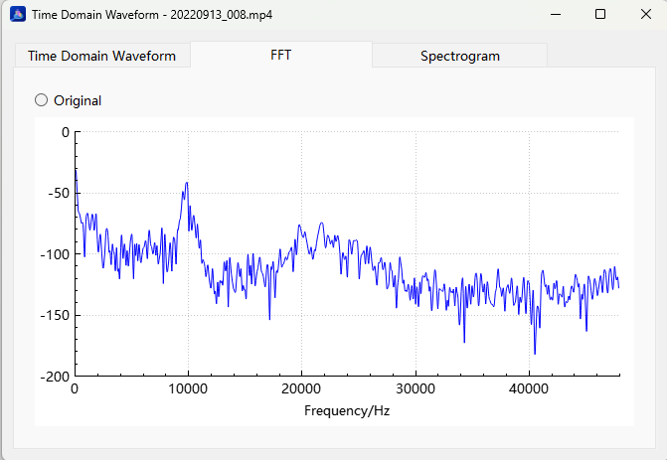

Spectrogram
Including the entire audio data.
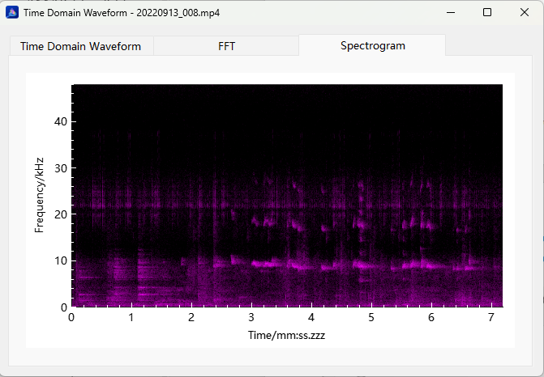

PRPD（Electricity）
Tip：Displayed during video file playback.
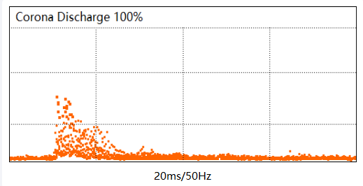
PRPD (Partial Discharge Pattern) spectrum and discharge type display
Analyze the audio data and plot the PRPD (Partial Discharge Pattern) spectrum in conjunction with the pddtemp.txt file. Display the PRPD spectrum, discharge type, and synchronization frequency corresponding to the current image frame. If there is no audio data, it will be displayed as blank.

Test Result Determination
Test Result Determination Entry
Analyze the various data of the current file and fill in the test result determination. It can be exported to the report.
- Fault Level：Select from the dropdown menu.
- Discharge Type (Electricity): Type of localized discharge for the sound source. If there is no audio data, manually enter the information.
- Maintenance Advice: Measures for addressing the leakage source/localized discharge point.
- Export Annotations (ISO50001 Gas Report): Corresponds to the button in "File Annotations." Check the checkbox to export images and text annotations. A maximum of two image annotations can be exported per file.
- Judgement Basis (ISO50001): Export to the report.

Economic Loss Estimation (Gas)
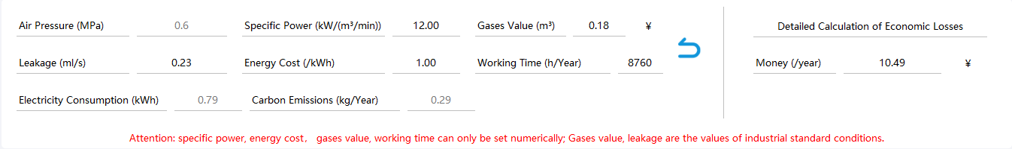
Economic Loss Estimation
Estimate the economic loss based on the leakage amount and the set loss parameters.
- Air Pressure: Read from info.dat file, cannot be modified.
- Leakage: Leakage amount corresponding to the current image/video frame.
- Specific Power/Energy Cost/Gases Value/Working Time: Read from info.dat file, or manually set through "Settings -> Economic Loss Parameters." If the parameter is not included in info.dat, the parameter value set in the analysis software will be used.
- Restore File Parameter Settings: Button available when loss parameters are present in info.dat; clicking it will restore the parameter values to those in info.dat if any manual modifications were made.
- Electricity Consumption: Calculated based on the gas leakage amount, cannot be modified.
- Carbon Emissions: Calculated based on the gas leakage amount, cannot be modified.
- Money: Calculated based on the parameters on the left side, cannot be directly modified.

Appendix A Custom Gas Report (XLSX)
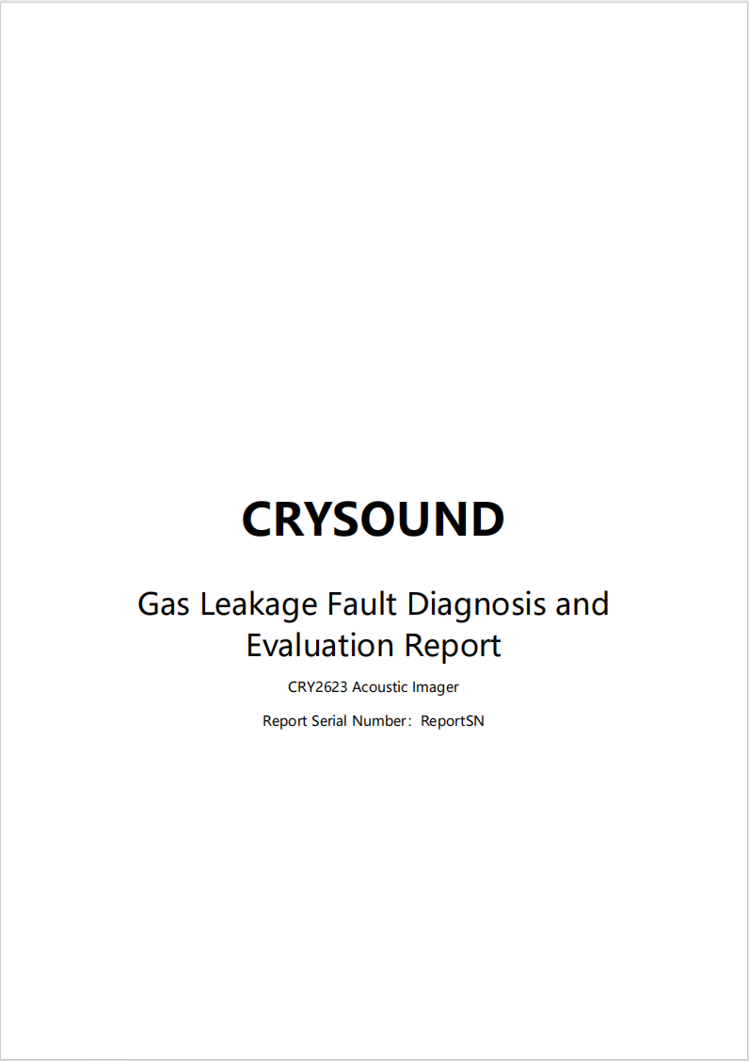
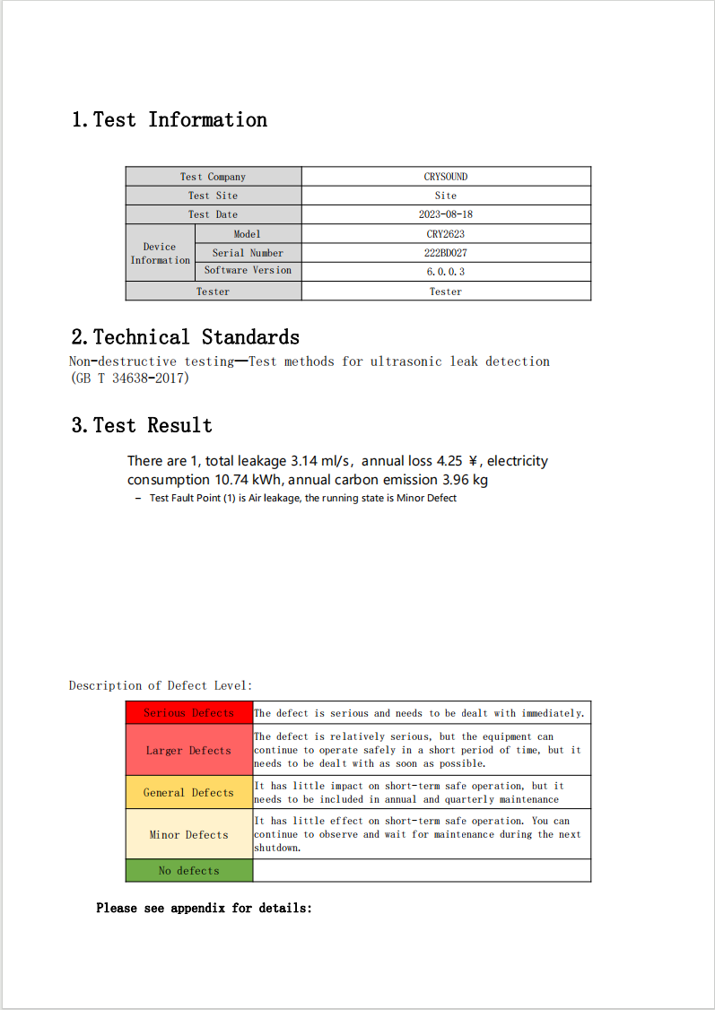
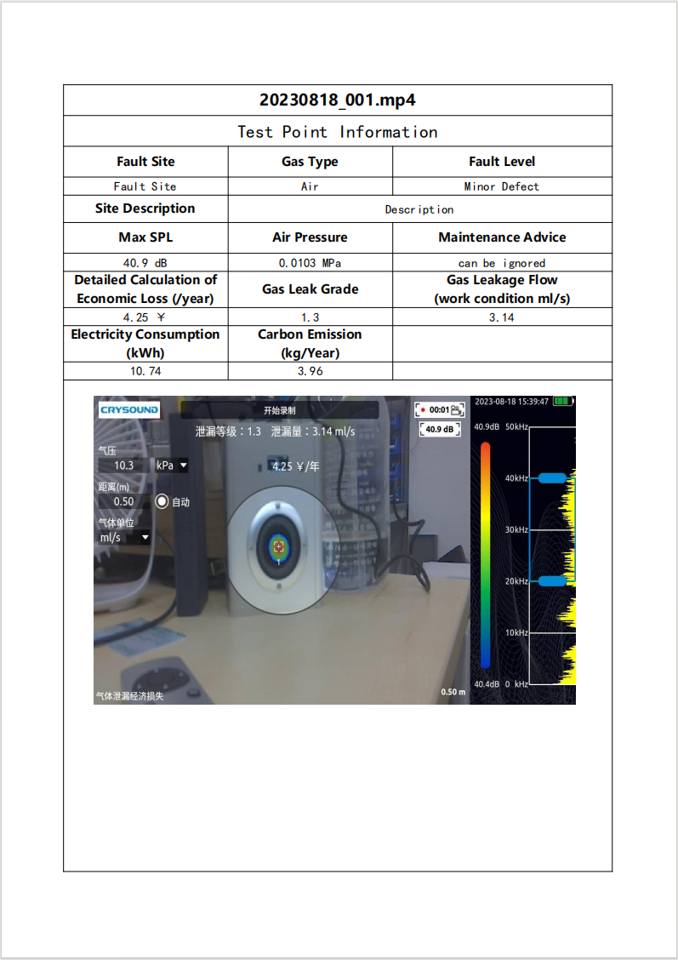

Appendix B Custom Electricity Report (XLSX)
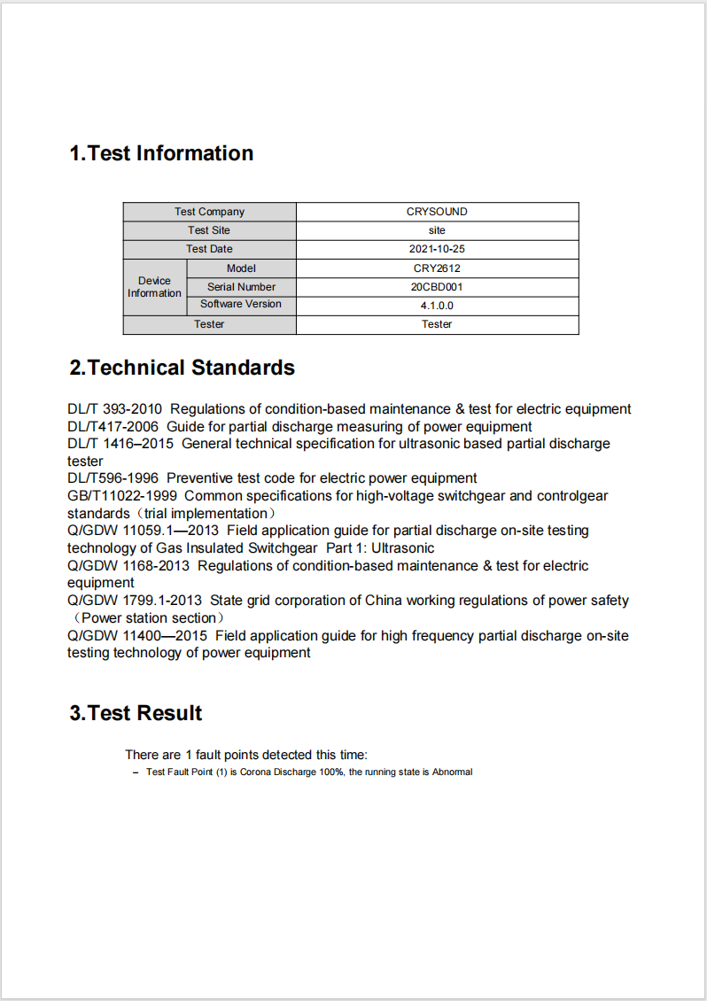
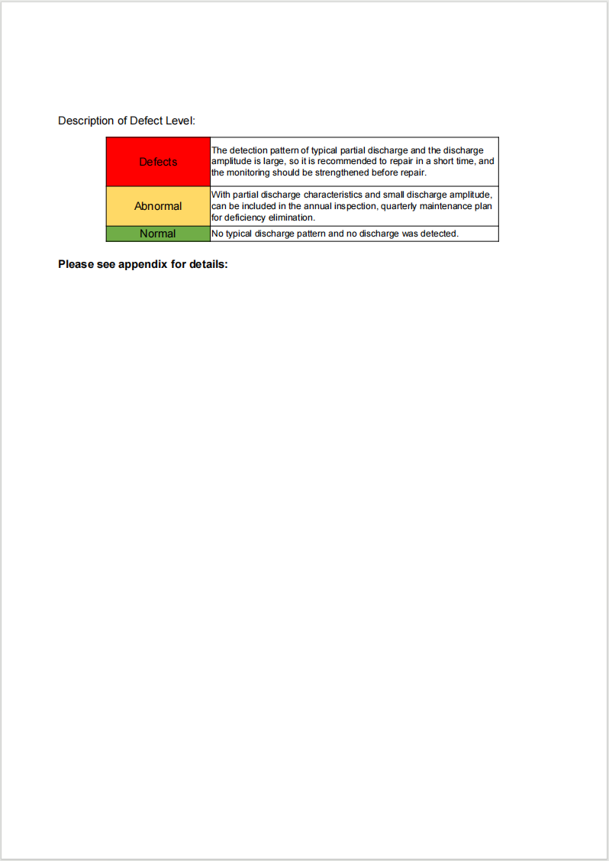
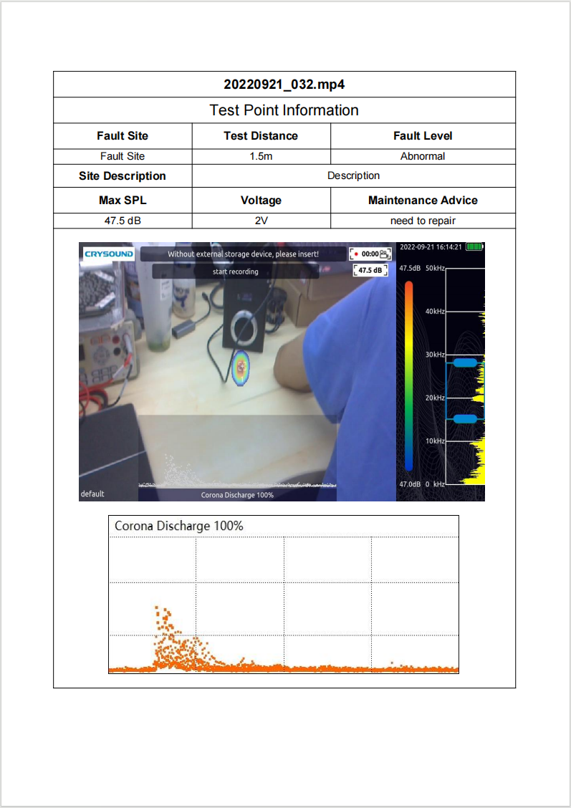

Appendix C ISO50001 Gas Report (PDF)
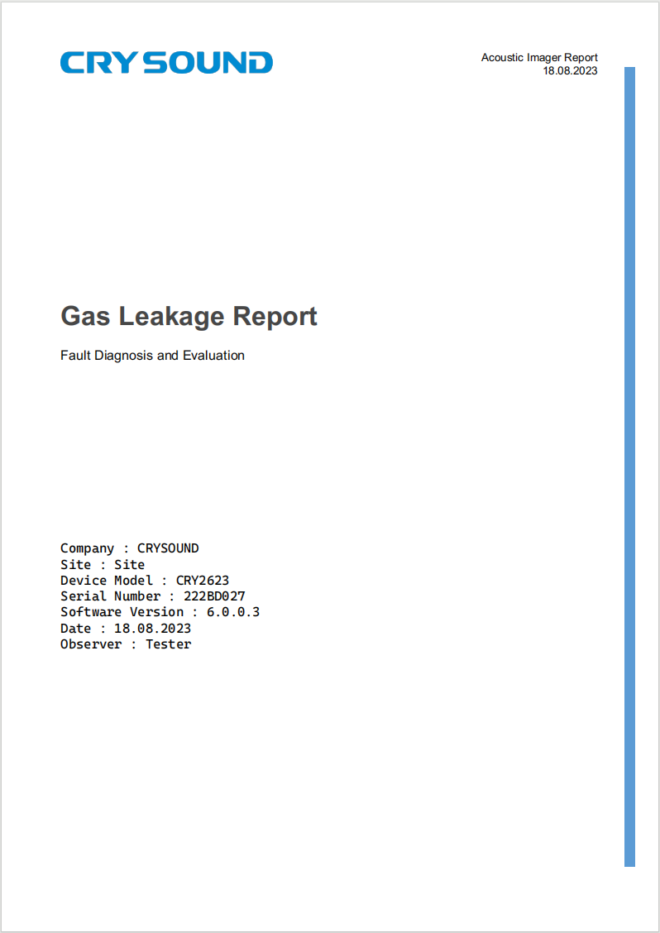
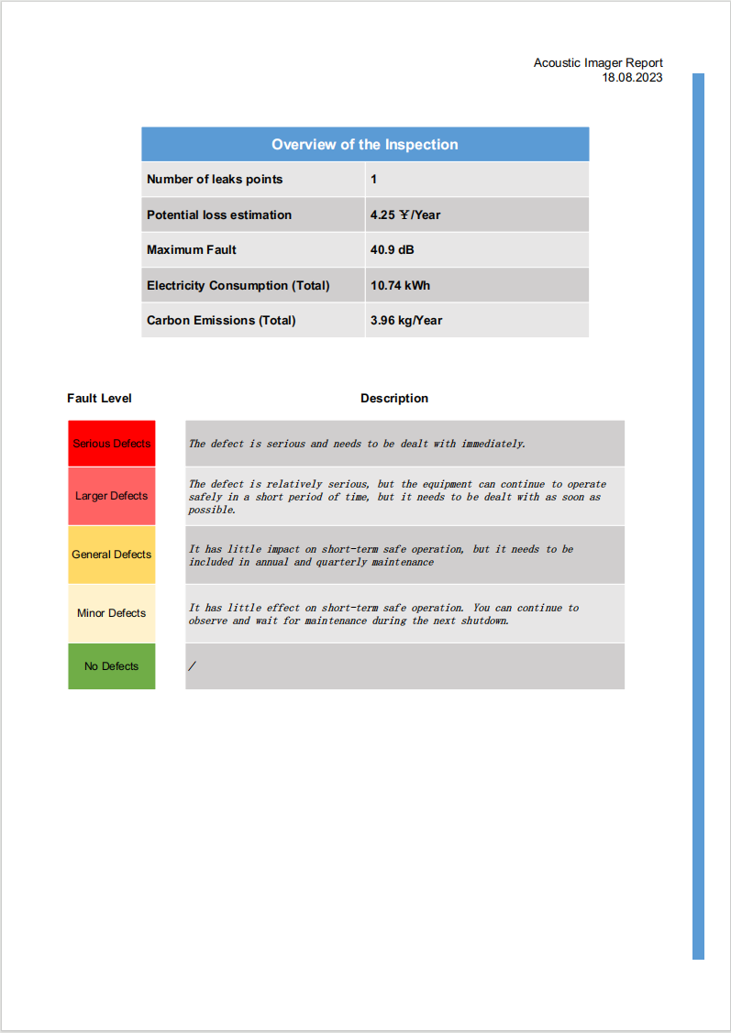
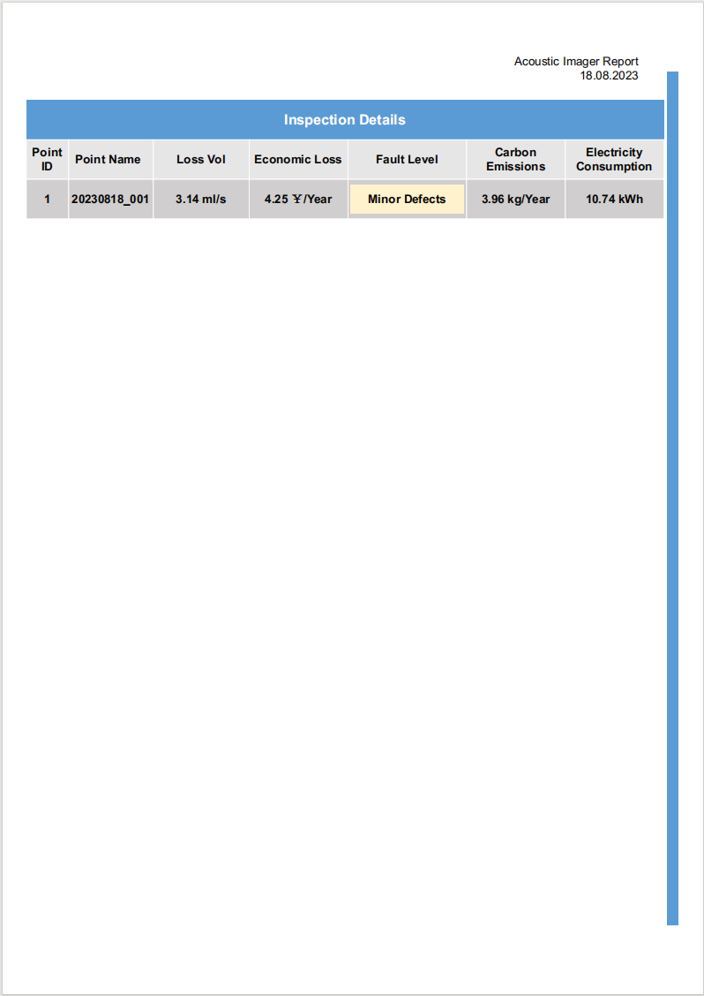
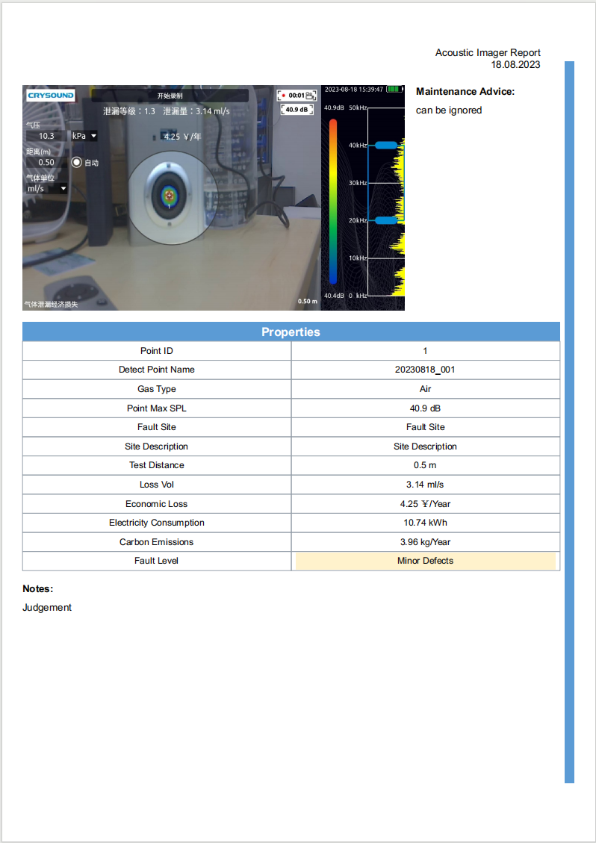

Appendix D ISO50001 Electricity Report (PDF)
